The model you provided is a LoRA-fine-tuned version of a quantized LLaMA-style model using PEFT (Parameter-Efficient Fine-Tuning) and 4-bit quantization for inference efficiency.
Here’s a clear breakdown of the architectural changes between the original LLM and the fine-tuned version:

🧠 Summary of Changes from the Original LLM
Aspect | Original LLM | Fine-Tuned Model
Model Type | LlamaForCausalLM | PeftModelForCausalLM (via LoRA)
Attention Layers | Standard Linear layers for q, k, v, o projections | Wrapped with lora.Linear4bit modules
Training Method | Full-model fine-tuning (or zero tuning) | LoRA applied only to a few modules
Weight Format | Full precision or fp16 | Quantized to 4-bit via bitsandbytes
Modified Components | Entire model | Only attention (q_proj, k_proj, v_proj, o_proj)
Extra Parameters | None | Adds LoRA A and B adapters per attention head
Dropout & Scaling | Not present in original projections | Includes lora_dropout, and LoRA alpha scaling

🔍 Structural Details of the Fine-Tuned Model
✅ 1. Model Wrapping Hierarchy
PeftModelForCausalLM
└── LoraModel
└── LlamaForCausalLM
└── LlamaModel (Decoder-Only Transformer)

✅ 2. Attention Projection Layers Replaced
Each of the following layers was originally a plain Linear:
- q_proj (query)
- k_proj (key)
- v_proj (value)
- o_proj (output)
They are now replaced with:
lora.Linear4bit(
base_layer = Linear4bit(...),
lora_A = Linear(in_features=..., out_features=r),
lora_B = Linear(in_features=r, out_features=...),
)
This means LoRA is injected as low-rank adapters on top of quantized base weights, and only LoRA parameters are trainable.

✅ 3. LoRA Rank (r=32) and Dropout
- lora_A: Reduces dimensionality from 4096 → 32
- lora_B: Projects back from 32 → 4096
- Dropout(p=0.1): Regularizes the inserted adapter
- These modules are stored in ModuleDict for modularity.

✅ 4. Quantization
- All base layers are Linear4bit, not standard PyTorch Linear, enabling inference with low memory footprint.
- Likely implemented via bitsandbytes.

🧪 Why This Is Good
- 🔋 Efficiency: Fine-tunes only a small % of parameters (~0.1–1%), saving GPU memory and training time.
- 💾 Compact Checkpoints: Only LoRA deltas are saved, reducing model size.
- 🔄 Reversible: The original model remains intact under the hood.
- 🤖 Useful for Transfer Learning: Effective even with limited training data.

✅ Final Takeaway:
You started from a pre-trained LLaMA model, applied quantization and LoRA adapters only to the attention projections, and wrapped it with PeftModelForCausalLM to make it parameter-efficient and trainable without touching the full model weights.

Visual diagram of this structure or code to merge LoRA weights into the base model for inference.
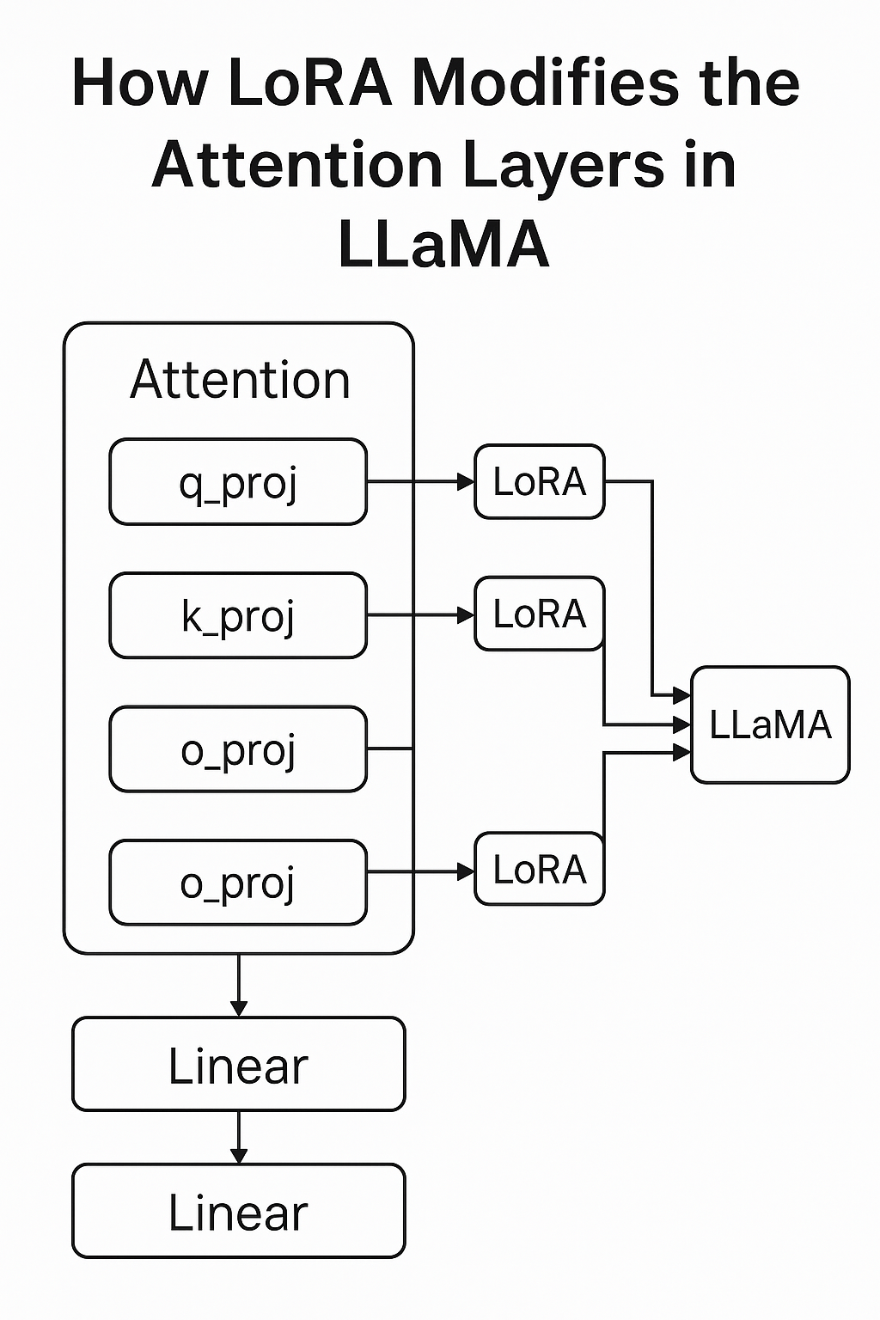

Fine tuned model is a textbook example of QLoRA applied to a Base LLM (like LLaMA).

✅ Breakdown: QLoRA vs Base LLM
Feature | Base LLM | Your Fine-Tuned Model (QLoRA)
Model Type | Full-precision LLaMA model | Quantized LLaMA with LoRA adapters
Quantization | None or FP16/BF16 | ✅ 4-bit quantization (Linear4bit)
Trainable Params | All layers (very large) | ✅ Only LoRA adapters (very small)
PEFT (LoRA) | ❌ No adapters | ✅ LoRA on q_proj, k_proj, v_proj, o_proj
Memory Efficient? | ❌ No | ✅ Yes – both during training and inference
Checkpoint Size | 6B–30B full weights | ✅ ~<1% of original size (just LoRA deltas)
Training Goal | Full model finetune | Efficient adaptation of a quantized model

🧠 What is QLoRA?
QLoRA = Quantized LLM + LoRA Adapters
QLoRA was designed to:
- Enable fine-tuning of large models on consumer GPUs
- Combine 4-bit quantization (via bitsandbytes) with LoRA parameter-efficient training
- Preserve full model behavior with very few learnable parameters
📌 You’re using LoraModel + Linear4bit inside a PeftModelForCausalLM → that’s the exact implementation of QLoRA.

✅ Final Verdict:
Yes — you're running QLoRA fine-tuning on a base LLaMA-style LLM, which is:
- Memory-efficient ✅
- Parameter-efficient ✅
- Effective for domain adaptation ✅

LLM Base Model
LlamaForCausalLM(
(model): LlamaModel(
(embed_tokens): Embedding(128256, 4096)
(layers): ModuleList(
(0-31): 32 x LlamaDecoderLayer(
(self_attn): LlamaAttention( => 1
(q_proj): Linear(in_features=4096, out_features=4096, bias=False)
(k_proj): Linear(in_features=4096, out_features=1024, bias=False)
(v_proj): Linear(in_features=4096, out_features=1024, bias=False)
(o_proj): Linear(in_features=4096, out_features=4096, bias=False)
)
(mlp): LlamaMLP( => 2
(gate_proj): Linear(in_features=4096, out_features=14336, bias=False)
(up_proj): Linear(in_features=4096, out_features=14336, bias=False)
(down_proj): Linear(in_features=14336, out_features=4096, bias=False)
(act_fn): SiLU() => 3
)
(input_layernorm): LlamaRMSNorm((4096,), eps=1e-05)
(post_attention_layernorm): LlamaRMSNorm((4096,), eps=1e-05)
)
)
(norm): LlamaRMSNorm((4096,), eps=1e-05)
(rotary_emb): LlamaRotaryEmbedding()
)
(lm_head): Linear(in_features=4096, out_features=128256, bias=False) => 4
)

Fine tuned Model
PeftModelForCausalLM(
(base_model): LoraModel(
(model): LlamaForCausalLM(
(model): LlamaModel(
(embed_tokens): Embedding(128256, 4096)
(layers): ModuleList(
(0-31): 32 x LlamaDecoderLayer(
(self_attn): LlamaAttention(
(q_proj): lora.Linear4bit(
(base_layer): Linear4bit(in_features=4096, out_features=4096, bias=False)
(lora_dropout): ModuleDict(
(default): Dropout(p=0.1, inplace=False)
)
(lora_A): ModuleDict(
(default): Linear(in_features=4096, out_features=32, bias=False)
)
(lora_B): ModuleDict(
(default): Linear(in_features=32, out_features=4096, bias=False)
)
(lora_embedding_A): ParameterDict()
(lora_embedding_B): ParameterDict()
(lora_magnitude_vector): ModuleDict()
)
(k_proj): lora.Linear4bit(
(base_layer): Linear4bit(in_features=4096, out_features=1024, bias=False)
(lora_dropout): ModuleDict(
(default): Dropout(p=0.1, inplace=False)
)
(lora_A): ModuleDict(
(default): Linear(in_features=4096, out_features=32, bias=False)
)
(lora_B): ModuleDict(
(default): Linear(in_features=32, out_features=1024, bias=False)
)
(lora_embedding_A): ParameterDict()
(lora_embedding_B): ParameterDict()
(lora_magnitude_vector): ModuleDict()
)
(v_proj): lora.Linear4bit(
(base_layer): Linear4bit(in_features=4096, out_features=1024, bias=False)
(lora_dropout): ModuleDict(
(default): Dropout(p=0.1, inplace=False)
)
(lora_A): ModuleDict(
(default): Linear(in_features=4096, out_features=32, bias=False)
)
(lora_B): ModuleDict(
(default): Linear(in_features=32, out_features=1024, bias=False)
)
(lora_embedding_A): ParameterDict()
(lora_embedding_B): ParameterDict()
(lora_magnitude_vector): ModuleDict()
)
(o_proj): lora.Linear4bit(
(base_layer): Linear4bit(in_features=4096, out_features=4096, bias=False)
(lora_dropout): ModuleDict(
(default): Dropout(p=0.1, inplace=False)
)
(lora_A): ModuleDict(
(default): Linear(in_features=4096, out_features=32, bias=False)
)
(lora_B): ModuleDict(
(default): Linear(in_features=32, out_features=4096, bias=False)
)
(lora_embedding_A): ParameterDict()
(lora_embedding_B): ParameterDict()
(lora_magnitude_vector): ModuleDict()
)
)
(mlp): LlamaMLP(
(gate_proj): Linear4bit(in_features=4096, out_features=14336, bias=False)
(up_proj): Linear4bit(in_features=4096, out_features=14336, bias=False)
(down_proj): Linear4bit(in_features=14336, out_features=4096, bias=False)
(act_fn): SiLU()
)
(input_layernorm): LlamaRMSNorm((4096,), eps=1e-05)
(post_attention_layernorm): LlamaRMSNorm((4096,), eps=1e-05)
)
)
(norm): LlamaRMSNorm((4096,), eps=1e-05)
(rotary_emb): LlamaRotaryEmbedding()
)
(lm_head): Linear(in_features=4096, out_features=128256, bias=False)
)
)
)

